NOTICE OF SPECIAL
SCHOOL BOARD MEETING
PLEASE TAKE NOTICE THAT THERE WILL BE A SPECIAL MEETING OF THE BOARD OF EDUCATION OF SPRING LAKE PUBLIC SCHOOLS, SPRING LAKE, MICHIGAN:

DATE OF MEETING: MONDAY, MAY 17, 2021
PLACE OF MEETING: SPRING LAKE PUBLIC SCHOOLS
Physical Location:
IS/MS Media Center
345 Hammond St.
Spring Lake, MI 49456
Sign Up/Join at Zoom.us Click here for meeting link
HOUR OF MEETING: IMMEDIATELY FOLLOWING 7:00 P.M. REGULAR MEETING

TELEPHONE NUMBER OF
PRINCIPAL OFFICE OF
BOARD OF EDUCATION: 616-847-7919
BOARD MINUTES ARE
LOCATED AT THE PRINCIPAL
OFFICE OF THE BOARD OF
EDUCATION: 345 HAMMOND ST.
SPRING LAKE, MI 49456

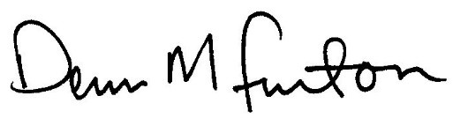
Dennis M. Furton, Superintendent of Schools

